Who is afraid in this story
Mary and Joseph
Herod who was challenged by the thought of a new king. Flee to Egypt. then Archelaus causing Joseph’s small, new family to settle in Nazareth, far from Bethlehem in the North of Israel.
Magi
Anyone with young children under Herod’s rule

Who is afraid in the Christmas story
The shepherds
Mary when she the angel appeared to her
Zechariah when the angel appeared to him
Joseph son of David, do not be afraid to take Mary home as your wife, because what is conceived in her is from the Holy Spirit. Joseph afraid of society’s censure

Picture of magi from the 200’s AD in a roman catacomb

Magi
not translated Kings or Wise Men. They followed stars and looked for omens. Like sorcerers. Ancient Zoroastrian or Persian priests. Interpreters of omens and dreams.

Where are we going to put these magi?

Traditionally celebrated 6th January – hence 12 days of Christmas. Some traditions have it 2 winters after Christmas. Almost certainly not on the other side of the shepherds who were there on the first Christmas day , the day Jesus was born. The Sunday School nativity plays needed parts for all the children and dress them as kings. The evidence is in the passage we just read.
Herod needed time to realise that the travelers from the East were not returning.

How many shepherds should there be in the nativity scene? How many Magi?

The story is a curious one to put on at the time of Christmas. We sang Joy to the World last week
Also in Funny Kind of Night one of the verses
Funny kind of day, funny kind of night,
Babies cry, traditions die, and fear itself takes fright;
Country folk enquire what is right or wrong
I might have challenged a few traditions today for some of you.

This story reminds us that not everyone is cheery at Christmas.
- Some live in fear
- Some are stressed remembering fear
- Many watch global trends and wonder what their world will be like in their lifetime or their grandchildren’s lifetime.
- I contacted someone who has been in mental hospital for a couple of weeks.
- Some don’t connect with their families anymore. Both sides probably live with regret
- The season’s celebrations are not the same for some who have lost loved ones or they are far away.
Not everyone who hears the Christmas message is in a place of safety.
At the Christmas celebration at the sportsground Michael mentioned Blue Christmas Service- for people who find this time of year very challenging. That kind of service would be a lament. In the Northern Hemisphere it would be held around 21 Dec which is the longest and darkest of nights. 21st Dec is also designated Gravy Day in Australia from Paul Kelly’s ballad using the voice of a man in gaol missing his family.

(man with head in hands)

Jesus was a refugee
Jesus fled to Egypt in tow with his family. We know that it is the most vulnerable who suffer most in times of insecurity, disaster or persecution. The poor, the young, women or sick and frail.

Slide of vulnerable

At the end of June 2025, 117.3 million people worldwide were forcibly displaced as a result of persecution, conflict, violence, human rights violations or events seriously disturbing public order.

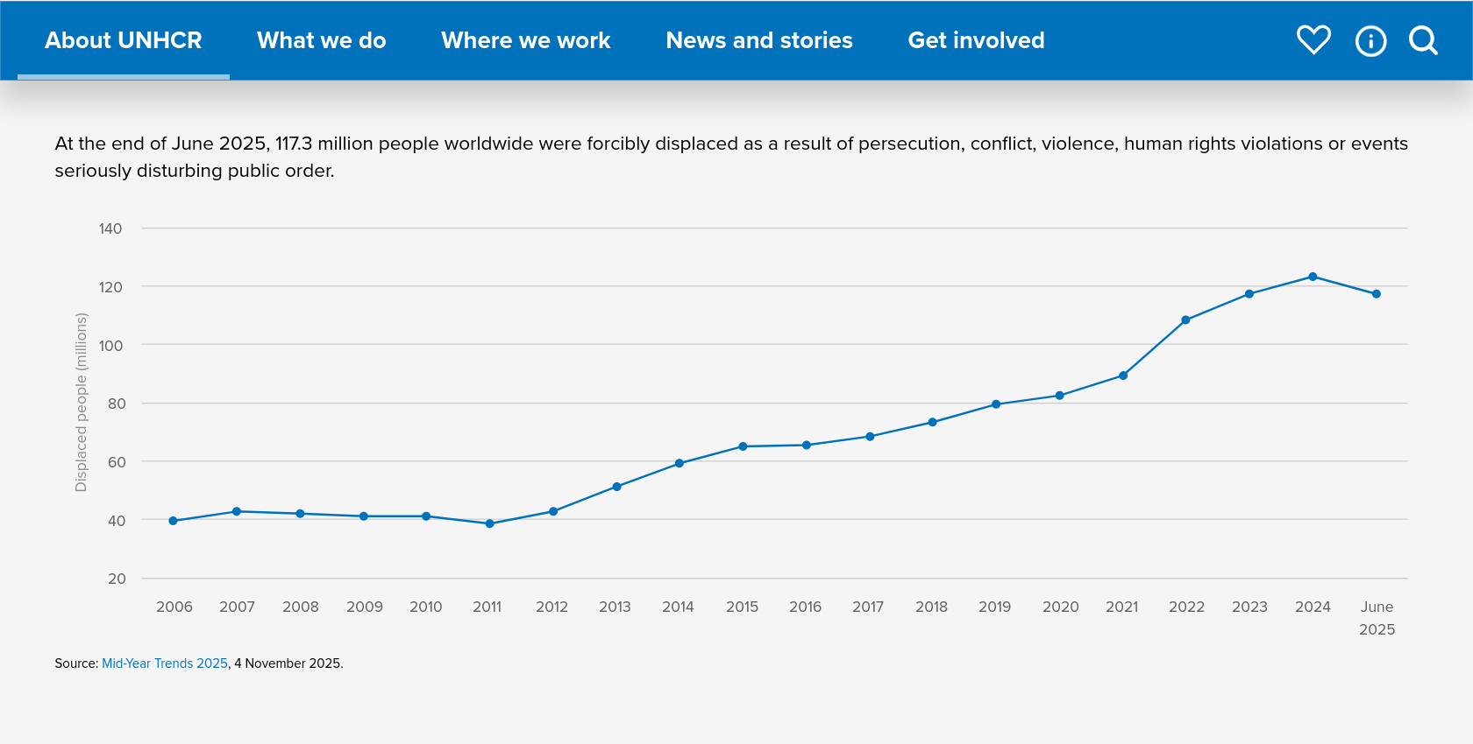
2/3 of those people had left their homes and are classified as displaced people as they still live somewhere in their original country. They may still be cared for in refugee camps or fending for themselves. About 40 million people have left their country as refugees.
4 million are stateless where no country recognises them as citizens.

Where does Aust fit in our response to refugees. Generous or not.

In terms of official resettlement we rank highly
In terms of per capita intake, or caring for refugees. Australia falls significantly behind countries like Lebanon, Jordan, and Montenegro, ranking 72nd with 2.08 refugees per 1000 population. In addition, when considering the relative wealth of the nation, Australia’s refugee intake is even less impressive, ranking 109th with 35 refugees for every $1 billion of GDP. This places Australia far behind countries like Chad, Uganda, and Lebanon, which host significantly more refugees relative to their GDP.

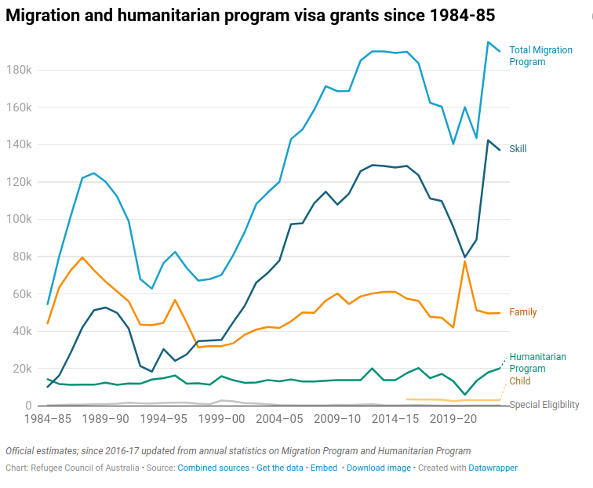

If I were to think again of tradition challenging. - Let’s come back to Jesus.
He challenged
- that might is right
- that scripture must be interpreted generously for those in powerful
- that what seems hopeless can be rescued with God’s help. God does not hold the world at arm’s length.
- that fear is not the endpoint.
- That security is not everything.

The follow-up story after the Magi’s visit that we read today reminds us that God is still with us in control, even in times of darkness.
We now look to a better world, a hope in the future for us individually and pray for a more empathetic and generous world as a whole.
We can acknowledge suffering and finding hope in the promise of Christ's coming, "Immanuel" (God with us). Which introduces our next song.

