How can we find Shelter in our very troubled world?
Well it’s not the kind of shelter we would think of as shelter. It is how we can cope with living amongst evil or terrible things. And remember that all the protections are given to us from God himself.
Ephesians 6: 10-18
Put on the whole armour of God

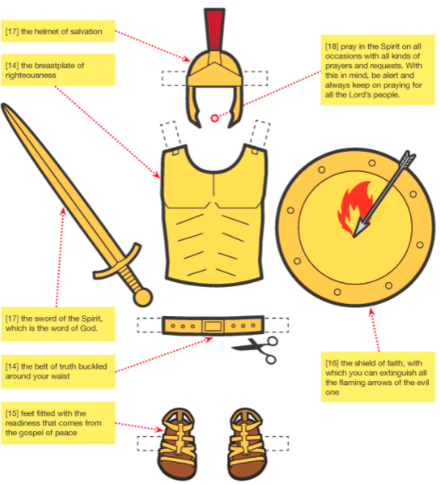

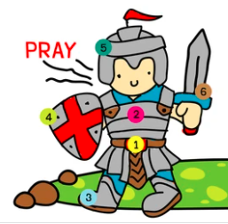
Use the information from the first picture on page 1, and write what each number represents in the picture to the left. I’ve done one for you.

1.
2. Breastplate of Righteousness
3.
4.
5.
6.
What kind of attacks might we expect:
- Doubting what we learn about Jesus and our salvation
- Attack on our emotions so we have self-doubt, great fear, anger
- Following the wrong leaders
- Lies
- Insults and setbacks. Ideas, which acted upon, would bring harm to others.
- Not being ready because we have not studied God’s word and PRAYED to know God’s plan for us.
Can you think of others? Can you draw one of the attacks we might expect.

