11 April 2021 Second Sunday of Easter B Peace that breaks through locked doors
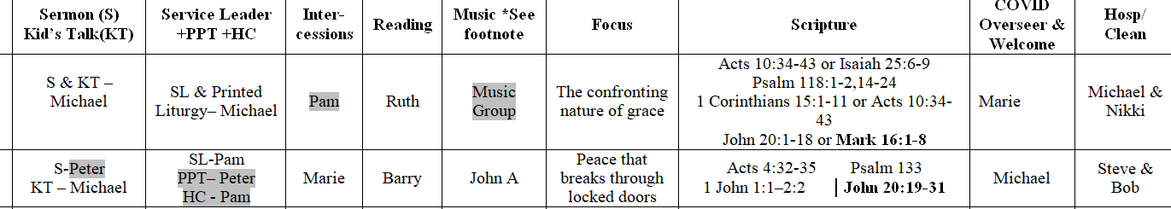

Acts 4:32-35 Psalm 133 1 John 1:1–2:2 John 20:19-31

CALL TO WORSHIP
The doors to the church are open, we have entered into this place at this time choosing to come and worship the God of life.
God’s peace dwells here with us and within us. Let us worship, God.

PRAYER OF INVOCATION
Living God, Come enter this house of worship in which we gather today.
Break through the walls we build around us that separate us from your love and peace and the companionship of our neighbours. Speak into our hearts the possibilities of new life and new ways of encountering you. Amen.

Blessed
Blessed are those who dwell in Your house They are ever praising You

Psalm 133 – Barry reading

Kid’s/Interactive - Michael

PRAYER OF CONFESSION
God of life, We confess that it is easy to close ourselves off from the world when things are tough and confronting.
In uncertain times it is easy to lock ourselves in a bubble of knowledgeable ignorance.
In times of fear and scarcity it is easy for us to close the door on people in need.
In moments of conflict it is easy to build a barrier that inhibits communication and engagement between ourselves and those with whom we disagree.
In moments of shame and when we are distressed it is easier to turn away than confront what is before us.
And yet we claim to be people of faith who live out your resurrection. Remind us God, that we are not promised an easy road nor an easy life – Easter is not about what’s easy – we need only look at your scarred hands to know this. It’s about restoration and what’s life giving.
WORDS OF ASSURANCE
When we open our eyes and hearts to goodness, God will enter into our lives regardless of what barriers and barricades we might have put in place. Trust in this and let yourselves be led into the reconciling peace of God.
PRAYER OF ADORATION AND THANKSGIVING
God, you spoke life into what was void, and shaped all things on earth and in the heavens, our Easter Hallelujahs continue to echo in our hearts and we sing for joy of the great comfort that comes from knowing that you stand amongst us, that you offer us peace,
that you call us into family with you.

DISCIPLESHIP THOUGHT
There is tension in the house in which the disciples are gathered. The rooms are dark, the doors are locked. They are scared, going out might lead to being recognised and arrested, even torture and death. Who can they trust? They know it’s hard to tell a friend from an enemy. Things have ended very differently from how they thought their journey with Jesus would end. Mary says Jesus is alive, that she has seen him, they have not - is she a reliable witness?
Easter 2020 and much of last year saw us locked in our homes, out of our churches and restricted in our movements. Despite this, the church lived on, in homes, via the internet, letters in the post, through acts of kindness, and in people’s hearts as the Spirit led us to be something different. Closed doors have never been a barrier to the living Christ and today’s reading is a powerful illustration of this.

OFFERTORY
The gifts that we bring today can open up access to projects and circumstances that can change people’s and the planet’s life, and so we give with hopeful hearts.
OFFERTORY PRAYER
People of God, Thank you for your generosity and faithfulness in continuing to give to the work of the church through your offerings here. We pray that they may be used in ways that promote peace and justice and open the gates of God’s realm of love in our world. Amen.

In Christ Alone

Acts 4:32-35 John 20:19-31 – Barry as reader

Talk 2 - Peter

INTERCESSION - Marie
The image of people being locked away and full of fear is one that is still common in our world today.
There are many places throughout the world where people are deprived of their liberty and forced to work in cruel, slave-like situations – in clothing factories, as domestic staff, in cocoa plantations and in the sex industry.
There continues to be detention centres and camps in which refugees and people seeking asylum are held in poor conditions with little hope of leaving.
There are those who find themselves in the grip of domestic violence believing that there is no way out.
There are people locked in pain and grief and confusion. Can we intervene in the world in such a way that even if such barriers and barricades remain hope and love can find their way inside?
God, there is no barrier that is impenetrable to your liberating grace. Grant us the courage to scale walls of injustice and breakdown those things that cause division between neighbours, the destruction of your good creation and diminish the integrity and dignity of your people. Let it be so.

Easter Hallelujah Mp4 Cassandra Star and Callahan

Communion -Pam

Nothing but the blood of Jesus

COMMISSIONING - Pam
May the peace of God that passes through locked doors, enter our hearts and minds today that we may continue on in the work of restoring life to all. Amen.

Someone (unnamed) told me that they might choose this Acts passage about the early followers shared life for this afternoon’s discussion on our communal values and direction

First a story from the early settlement of Melbourne about 180 years ago.
William Thomas was an Assistant Protector to the Aboriginal people in the new settlement of Melbourne. (Thomas was also a devout Methodist,) He lived among the Boonwurrung people, who are the traditional custodians of the land on which Melbourne now stands. In February of 1840, he made this observation in his diary:

They are generous amongst themselves. Those who are fortunate through the day will distribute amongst those who are unsuccessful. Those who are ill are not expected to tramp the bush for food. If children are left orphans those children [are]… supported among them… They live in the greatest harmony amongst themselves.
Quoted from Yalukit Willam: The River People of Port Phillip by Meyer Eidelson (City of Port Phillip: 2015) p 80. The Yalukit Willam are one of six groups that together form the Boonwurrung people.

Now let us turn to our text from the book of Acts:

Now the whole group of those who believed were of one heart and soul, and no one claimed private ownership of any possessions, but everything they owned was held in common… There was not a needy person among them, for as many owned lands or houses sold them and brought the proceeds of what was sold. They laid it at the apostles’ feet, and it was distributed to each as any had need. (Acts 4:32-35)
2 societies that are both very different to ours and hard to understand which were based on sharing. In fact I was hearing a radio program this week and she could remember from her childhood hearing the acts passage about the communal life of the disciples in Acts and the talk that it was ‘communist’. Which it pretty much is! How long did this practice last and does it work? Keep listening for modern examples that are working.
Compared to 19C Melbourne and 1stC Asia Minor and what we call the Near East and in our era which is much wealthier in almost all material senses Pam and I are encountering people every day who are facing homelessness with its associated anguishes

Visiting and being welcomed at Baptist monastery near Geelong
Modern Monastery as an intentional community.
Started as one family moved to a quiet street in Geelong who were willing to serve.

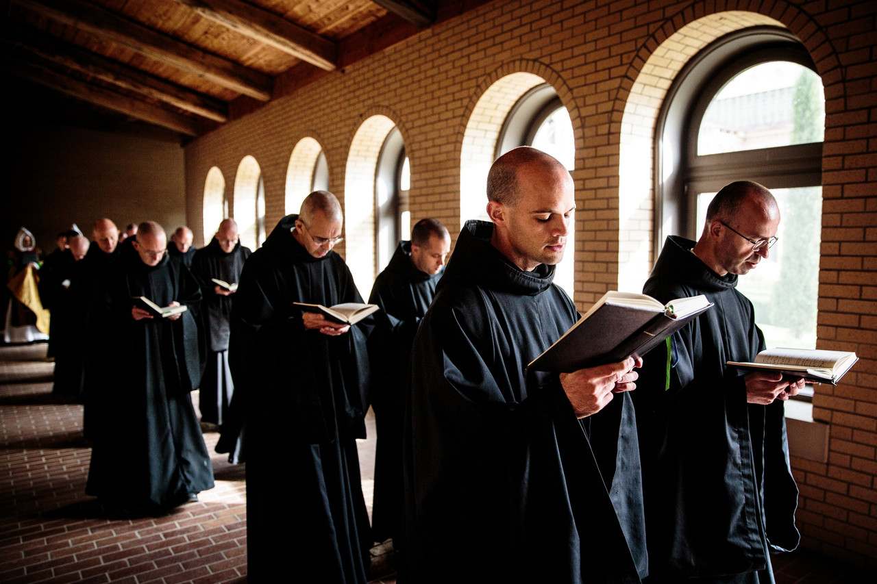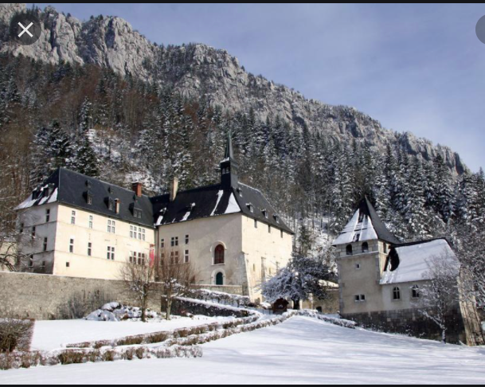

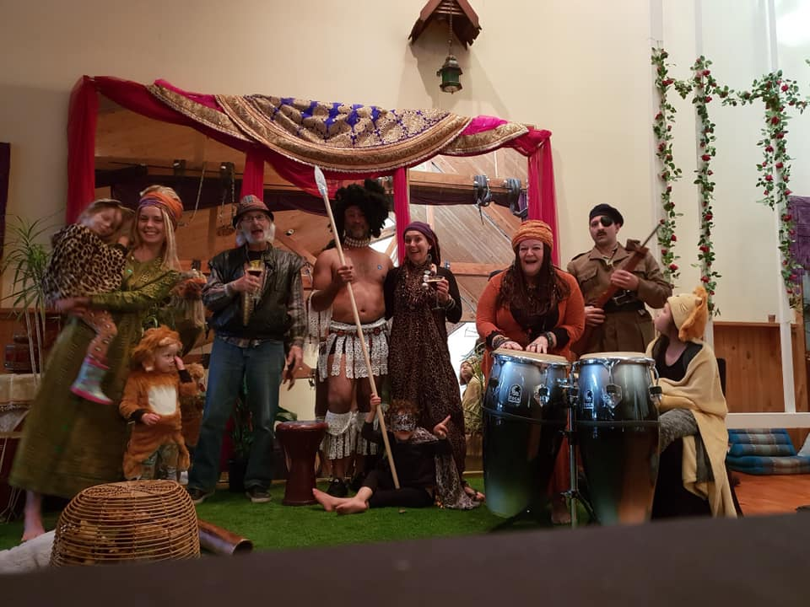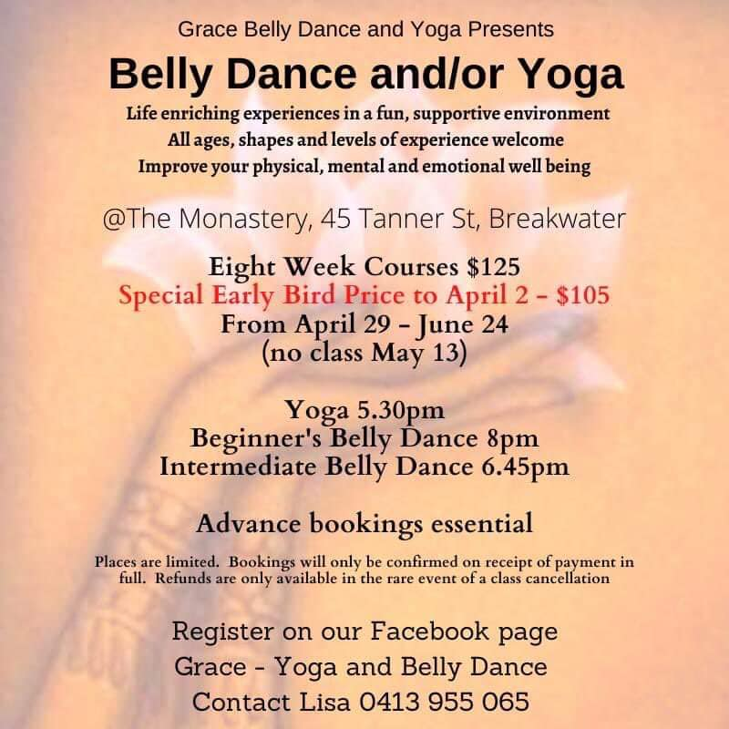
Thomas was the first person to reject the testimony of the early church. He virtually called the disciples, including Mary, who was the first witness to the resurrection, liars. So what did they do? They cast him out as a heretic, a non-believer. Not at all. They accepted the human frailty of doubt as they knew that they had theirs too and accepted that Thomas was on a journey of belief like us all.
What kind of love met the disciples behind those locked doors? — what did Martin Luther King say? “I’m not talking about emotional bosh. I’m talking about a tough, demanding love.” What does that looks like; how are you encountering it in the world today, love made public. Think a moment of where you see love in action. Where’s the home that demonstrates it? What institutions? What groups stand out as loving? Where does our congregation fit in? I’m sure this will come up in discussions later today.
Western Christianity has put an emphasis on the individual. It’s individual
- Repentance that counts
- Salvation is personal (which of course it has to be)
- Loving actions for which we individually are accountable
- Condemnation for selfish or greedy choices of the individual that counts
Consider what collectively as a nation, church, town, family or whatever group we belong to what
- Repentance might mean for a town
- Salvation for our nation
- Loving actions as a church family
- Condemnation for selfish or greedy choices in our politics or voting

Faith in Jesus is about following him, about trusting him and living the life he gives us. Like Thomas, many of us do that with all sorts of unresolved intellectual doubts about the historical or doctrinal content of the stories about Jesus. Jesus is not the least bit threatened by such doubts, and neither need we be, as his church. But Jesus is not threatened by that, and neither should we be. Faith in Jesus is not about eliminating doubts, let alone about ridding ourselves of the doubters.
Faith in Jesus is about honestly facing our doubts and choosing to commit ourselves to following Jesus anyway. John did not close this passage by saying I have written this down “so that you may come to believe that Jesus is the Messiah, the Son of God, and be accepted for the correctness of your doctrine.” Rather, he said I have written this down “so that you may come to believe that Jesus is the Messiah, the Son of God, and that through believing you may have life in his name.”

It is the living of the life that counts, and like Thomas and Jan, the doubters are welcome to come and live the life with us, for in the midst of that living, the risen Christ is seen and known.
"Thou shalt love the Lord thy God" (from Deuteronomy and Jesus quotes this) is explained to mean "Act in such a manner that God will be beloved by all His creatures."
What are we as a church? How do we define ourselves? How do others define us? What are our values? Will we go where we don’t know?

Listening to a radio show and this reading was memorable from her childhood as someone said it was communist.
Rev. Serene Jones: I see it in so many places around our nation and around the world, where communities are struggling together to improve, collectively, the conditions of their life, whether it be on the border or in Chicago, New York City; in Argentina or Yemen. Love persists. And it’s a remarkable, almost miraculous thing that love persists.

`Well, this is where the grace part becomes so important, because in my theology — and this is part of what we need to reclaim; it is so deep in Christianity — is that we may be glorious and sinful, but God’s love is bigger than that. So the reason we, in repentance, walk in this direction is not because, as sinners, we’ve repented, and because we don’t want to go to hell and want to go to heaven, we’re gonna walk that way. It’s because you actually recognize that the truth of love points you in that direction.
Grace is more original, because grace wins. Our sinfulness is not the final word about who we are. And that means that in this theology, which is suffused through Christianity and we suppress it, is that the love of God, the love of the universe, spirit, however you describe it, is stronger and more powerful and persistent, larger, greater, more eternal, than anything we do. That’s grace. And that’s the grace that changes how we experience everything.
Yes. Our masks are falling. We know we can’t live in them anymore. They’re destroying us. But we haven’t yet figured out what it means to live together without those masks. And that’s where the quest, the daring, the exploration — that’s where the bigness of love, as the ultimate truth about the world and our lives, has to be present. I believe that we can’t do it on our own, if we don’t have that guiding force.

Psalm 133
What a great thing it is, LORD,
........when people can get along with one another,
................and live together in unity and mutual respect.
It is even more satisfying than holding the cup aloft
........and dancing in the rain of champagne
................on Grand Final day.
It is even more desirable than sitting by an open fire
........sharing chocolates and fine wine with a loved one.
It is even more beautiful than the monsoon rains
........turning the desert into a sea of wildflowers.
For you LORD created us to be one people,
........committed to one another, honouring one another,
................sharing the land and its blessings forever.
©2002 Nathan Nettleton LaughingBird.net

1 John 1:1 - 2:2
That which was in place from day one, which we have heard, which we have seen with our own eyes,
.........and which we have examined and touched with our own hands;
that which is all about the word of life,
...a life which was brought out into the open
......and which we have seen and spoken up about,
.........and which we are telling you is the unstoppable life
............that came from the Father and was unveiled to us;
that — all of that — is what we are announcing to you.
Having seen it and heard it ourselves, we are announcing it to you so that you may join us in friendship and partnership. In fact, the partnership we enjoy and are inviting you in on is with God and with God’s Son, Jesus the Messiah. We are putting all this down in print so that the joy we get from sharing it may be all the more complete.
........If we were to sum up the message Jesus taught us and which we are now teaching you, it would be this: God is pure light. There is not even a hint of anything shadowy in God.
........If we claim that we are in partnership with God while we are still living our lives in the shadows, then we are lying, and failing to live out the truth. But if, on the other hand, we live our lives openly in the light, just as God does, then we will be in full partnership with one another. In that case, the blood which God’s Son Jesus shed will not have been wasted on us, but will have succeeded in cleaning up the sin which had corrupted our lives. If we claim to be uncorrupted, we are kidding no one but ourselves, and what we are really missing is honesty and integrity. If we own up to our corrupt actions, the One who is unswervingly faithful and just will give us a full pardon and clean up all that is polluted and twisted within us. If we claim that we have not done anything corrupt, then we are calling God a liar, and God’s word has clearly not taken root within us.
........I love you like my own children, and I am writing these things to you to help you to steer clear of corrupt ways. But if one of you does do something wrong, it is not the end of the world. There is one who goes in to bat for us with God — Jesus the Messiah, the One who always gets things right. He made the ultimate sacrifice in the process of dealing with our corruption and the corruption of the entire world, so that it would not cut us or anyone else off from God.
©2003 Nathan Nettleton LaughingBird.net
Reading 1 – before the Michael’s interactive
Psalm 133 A psalm of David.
A song for pilgrims ascending to Jerusalem.

How very good and pleasant it is
when family members live together in unity!
It is like the precious oil on the head,
running down upon the beard,
on the beard of Aaron,
running down over the collar of his robes.
It is like the dew of Hermon,
which falls on the mountains of Zion.
For there the Lord ordained his blessing,
life for evermore.
__________________________________________________
Readings 2 – before Peter’s talk
Acts 4: 32-35
There was an extraordinary harmony in the group of those who had put their trust in Christ. They shared a common heart and a common spirit. They also shared their possessions, giving up claims of private ownership and holding everything in common. With electrifying effect, the apostles shared the stories of their experience of the resurrection of the Lord Jesus. The evidence of God’s generous love and mercy was apparent in all they did. No one among them was left battling to make ends meet, because those who owned houses and land sold up and handed over the proceeds to the apostles, with no strings attached, and the money was distributed to each person according to their needs.
©2003 Nathan Nettleton LaughingBird.net

John 20: 19-31
........It was a Sunday — the first day of the week — when the tomb was found empty. That same evening, the disciples met together. They locked all the doors of the house where they were meeting because they were afraid of being tracked down by the religious authorities. Suddenly, Jesus appeared and stood among them saying, “Good evening to you all!”
........He proceeded to show them the deep scars in his hands and side. The disciples, of course, were over the moon at seeing the Lord again. Jesus spoke again, saying, “All the best to you. God sent me into the world, and in the same way, I’m sending you.”
........Having said that, he breathed a big breath onto them and said, “Receive the Holy Spirit; all of you. If you forgive anyone who has sinned, then their sins are forgiven. If you withhold forgiveness for any sins, they remain unforgiven.”
........When this happened, Thomas — known as “the Twin” and one of the twelve — was missing. The other disciples told him that they had seen the Lord, but they couldn’t convince him. “I’m not falling for that one!” Thomas replied. “I’d have to see the nail holes in his hands before I’d believe it. In fact I’d have to feel the holes myself, and touch the spear wound in his side.”
........A week later, the disciples again gathered behind locked doors in the same house, and this time Thomas was with them. Despite the locked doors, Jesus came and stood among them again and said, “Good evening to you all!”
........Then he turned to Thomas and said, “Here are my hands, Thomas. Put your finger here in the wound.” And pulling up his shirt, he said, “And here is my side. You can put your hand in the hole. Let go of your doubts and trust me.”
........Thomas, of course, was blown away, and said, “You are my Lord and my God!”
........Jesus said to him, “Believing is not that hard when you’ve seen me, is it? Imagine how much God will smile on those who put their trust in me without ever having seen me!”
........The disciples saw Jesus do many other things that demonstrated to them the reality of who he was, but they have not all been written down in this book. But what has been written here has been written for you, dear readers, so that you will know enough to see that Jesus is the anointed One — the Son of God — and so that by putting your trust in him you can come to have real life: the life that he lived and shares.
©2001 Nathan Nettleton LaughingBird.net
HYMNS

Acts 4: 32-35
All praise to our redeeming Lord TiS.442 AHB.367”
Dear Father, Lord of humankind TiS.598 AHB.519
Help us accept each other TiS.648
Jesus put this song into our hearts TiS.670 SIS.569 ATEverybody.258
Now we come, our heavenly Father TiS.462
Sent forth by God’s blessing TiS.531 SA.76

Psalm 133
Behold how pleasant, how good it is SFGP.120
Come, Holy Spirit, Lord of grace TiS.403 AHB.312
Heart and heart unite together AHB.363

1 John 1: 1 to 2: 2
Christ is the world’s light, he and none other TiS.246 AHB.191
I want to walk as a child of the light TiS.643
Lord, the light of your love is shining TiS.675
My daughters and my sons hear tell TiS.363 AHB.(281)
O breath of God, breathe on us now TiS.408 AHB.321
Wash, O God, our sons and daughters TiS.493

John 20: 19-31
Breathe on me, breath of God TiS.407 AHB.320
Christ the Lord is risen again TiS.365 AHB.282
In Christ there is no east or west TiS.459 AHB.391
Love divine, all loves excelling TiS.217 AHB.148
O breath of life, come sweeping through us TiS.409 AHB.322
That Eastertide with joy was bright TiS.360ii AHB/276ii
These things did Thomas count as real TiS.649
Yours be the glory, risen, conquering Son TiS.380 AHB.303

