‘Love your neighbour as yourself.’
Romans 13:9
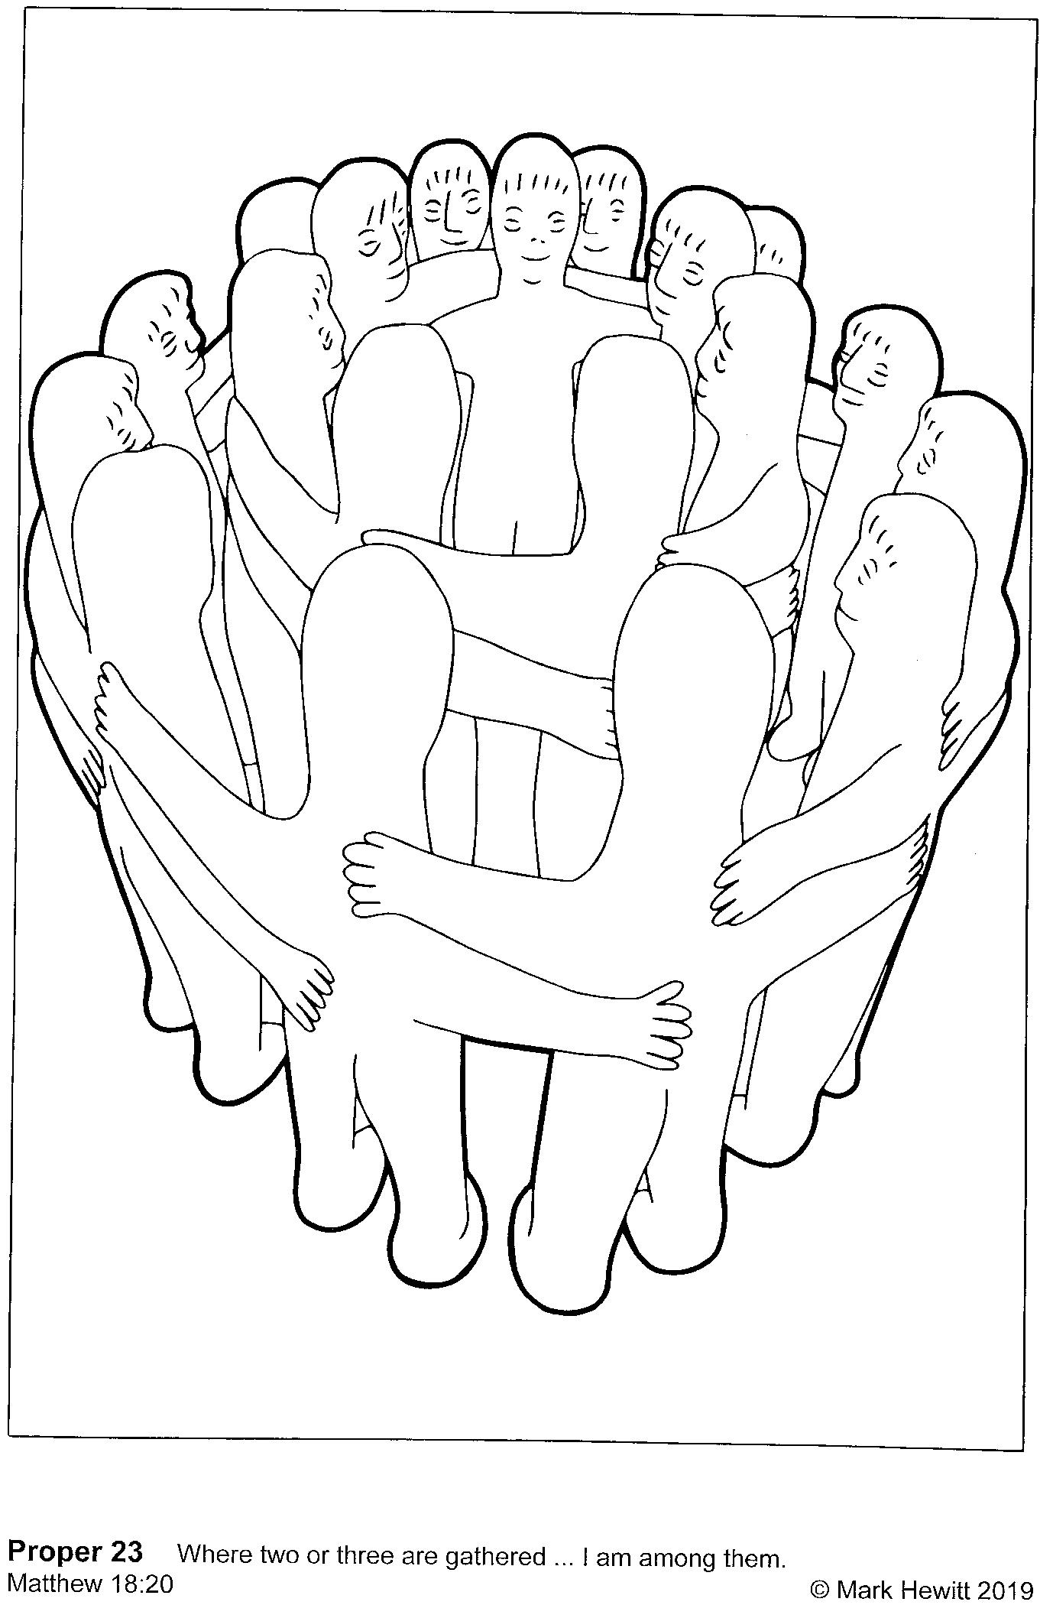
Can you make the people in this picture look like one of these-
- People in church
- People in your extended family
- Any group that needs to cooperate or work together

