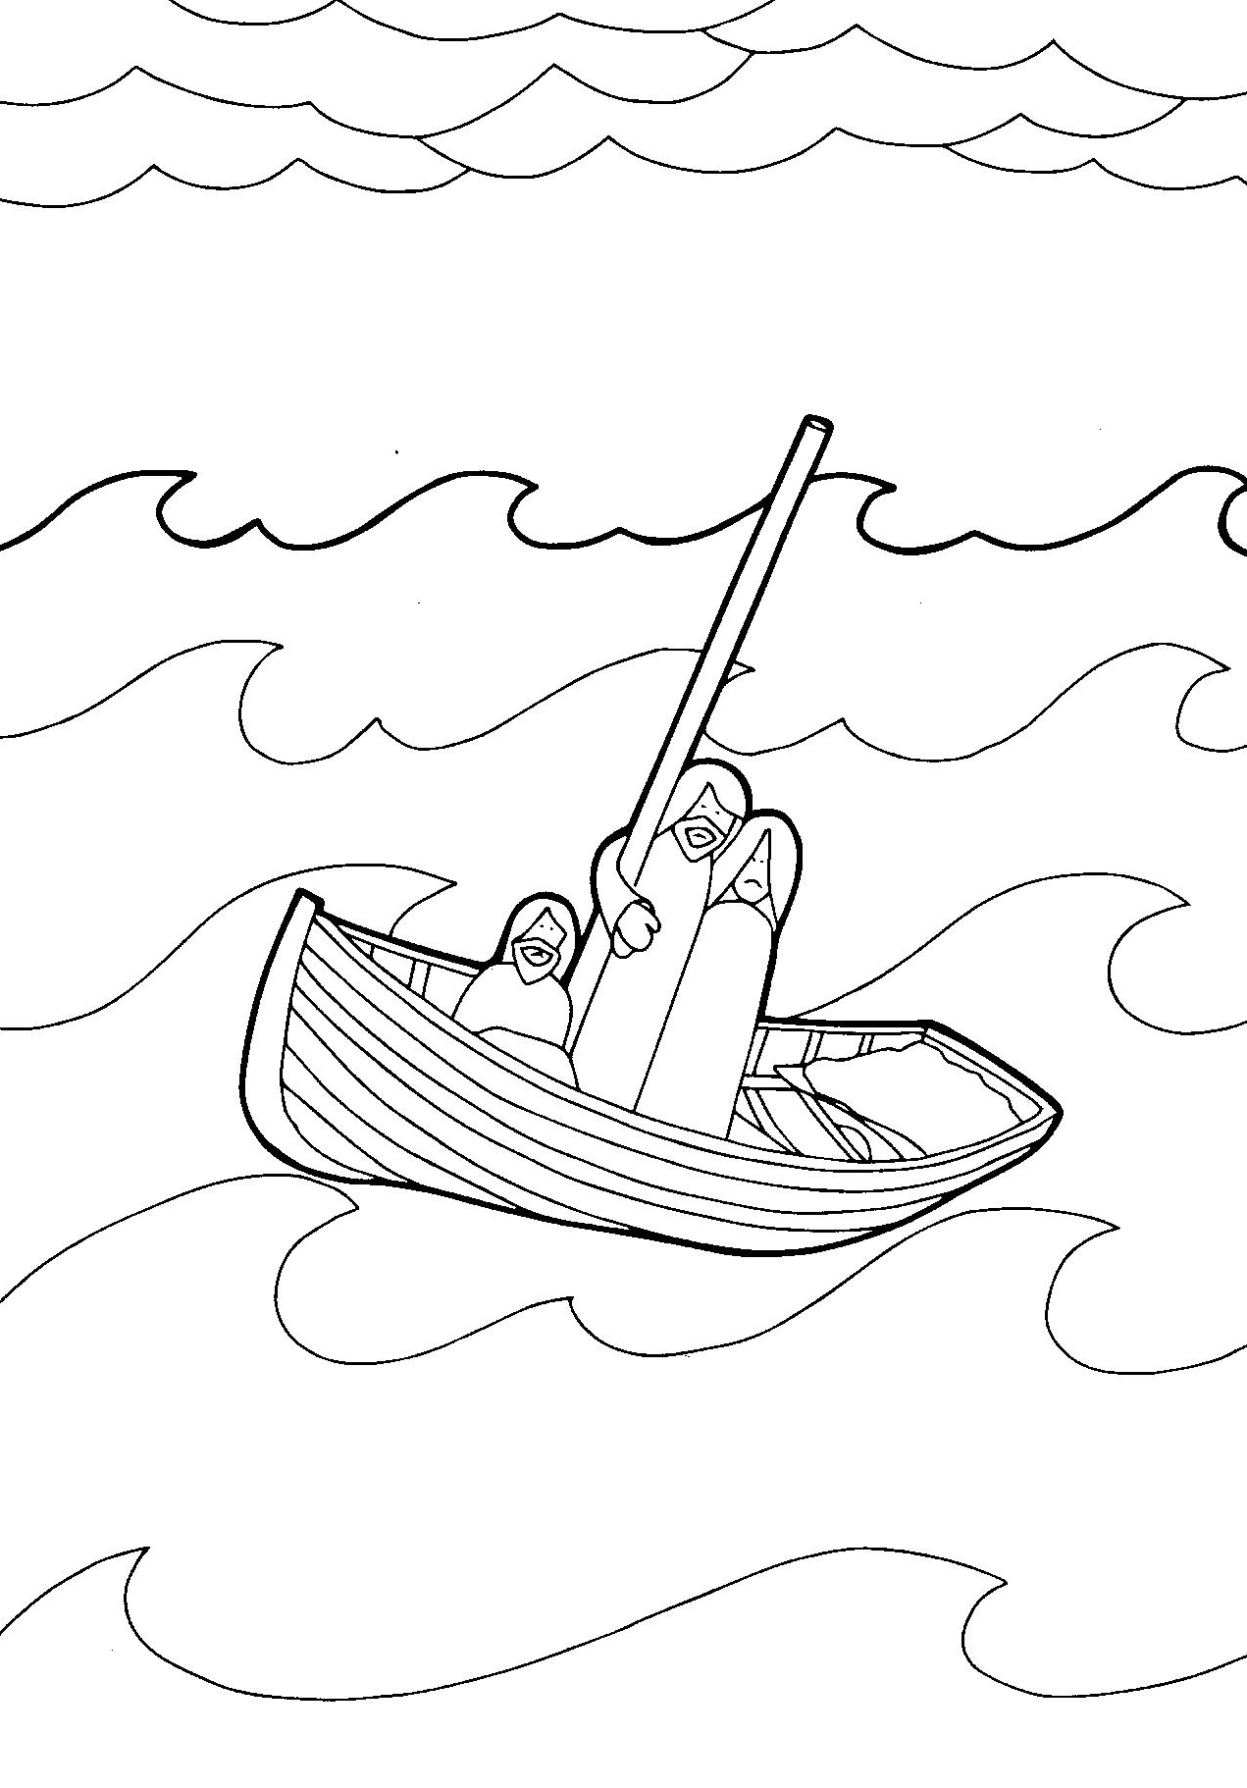
Draw in some missing parts of the picture
Colour the picture

Jesus walks on the water
Immediately Jesus made the disciples get into the boat and go on ahead of him to the other side, while he dismissed the crowd. After he had dismissed them, he went up on a mountainside by himself to pray. Later that night, he was there alone, and the boat was already a considerable distance from land, buffeted by the waves because the wind was against it.
Shortly before dawn Jesus went out to them, walking on the lake. When the disciples saw him walking on the lake, they were terrified. ‘It’s a ghost,’ they said, and cried out in fear.
But Jesus immediately said to them: ‘Take courage! It is I. Don’t be afraid.’
‘Lord, if it’s you,’ Peter replied, ‘tell me to come to you on the water.’
‘Come,’ he said.
Then Peter got down out of the boat, walked on the water and came towards Jesus. But when he saw the wind, he was afraid and, beginning to sink, cried out, ‘Lord, save me!’
Immediately Jesus reached out his hand and caught him. ‘You of little faith,’ he said, ‘why did you doubt?’
And when they climbed into the boat, the wind died down. Then those who were in the boat worshipped him, saying, ‘Truly you are the Son of God.’

