One person, one word. Children’s talk based on Hebrews Hebrews 13:1-8

One man. One word. Eternity. It’s the one word that has captivated the people of Sydney and beyond. For 30 years, from the 1930s to the 1960s, ‘Eternity’ was written in beautiful copperplate script with yellow chalk on the pavements of Sydney, country New South Wales, Newcastle and Melbourne

It took just one man, Arthur Stace, “Mr Eternity”, an Aussie battler, who had once been a drunk and criminal and then became a believer that Jesus could completely change his life for ever. Eternity was his favourite word and he decided to try and encourage as many people as he could to think about their life, their life after death and what is really important. Arthur’s story is an Australian story that one day you might want to read about. You can discover this true story in a book called Mr Eternity: The Story of Arthur Stace.
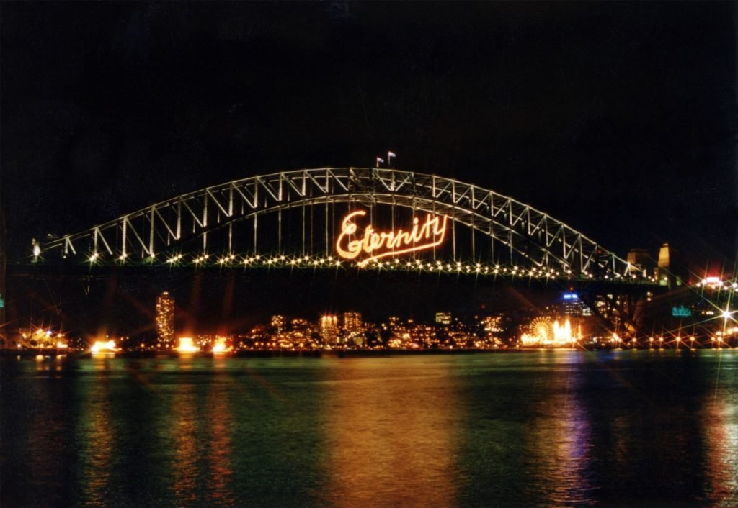
Do you have a favourite word? I have one and it is Enough.
Don't fall in love with money.
Be satisfied with what you have.
The Lord has promised that he will not leave us or desert us.
This should make you feel like saying,
“The Lord helps me!

When you fall in love with some thing or someone you think about the person or the thing a lot.
People might say, you are obsessed because it is like your whole life is only concerned about that one subject. It is all you want to talk about, maybe there seems to be nothing else to think about.

Perhaps you might be surprised to know that some people get to feel that way about money or even the stuff that money can buy.
Money is not a bad thing and things are not bad but if you are in love with money these wise words from the Bible are letting us know we must be careful about this. Wanting more and more money can be like an addiction, hard to stop and not good for you.
Why ?
Why should we be satisfied with what we have?
How can we know we have enough?.................

Sometimes it is hard to know.
But this part of Gods Word to us reminds us that God will look after us He will never desert us, forget about us or leave us completely alone.
That is a reassuring thought because if we believe this then we can also say ,
The Lord Helps Me!
He knows what we need and we will have enough.
When we have faith that we will always have enough of what we need then we live our lives differently, We feel more confident to care for others, to share what we have and not worry about running out for ourselves because God will Provide.
Some times this may feel hard, very hard. We might feel tested to our limits but here we must have faith.
Jehovah-jireh
Jehovah will see; i.e., will provide, the name given by Abraham to the scene of his offering up the ram which was caught in the thicket on Mount Moriah. The expression used in Genesis 22:14 , "in the mount of the Lord it shall be seen," has been regarded as equivalent to the saying, "Man's extremity is God's opportunity."
Choose a favourite word. Maybe you have more than one favourite word.
A word that you think is very important to how you might live your life.
Choose a piece of chalk and write your word on the steps of the church.
Write the word in colourful letters and think about what you might say to someone who asked you why you choose this word.

Arthur’s law
Is it legal to chalk?
In NSW - Yes. Section 4(5) of the NSW Graffiti Control Act protects the right to mark public footpaths or public pavements in chalk. It’s been called “Arthur’s law”. So … get chalking! But be careful not to do it on private property.
Be ready for the question!!
Why did you choose this word?

